Matt Adeola

5/12/21

Professor Barlow

OPMT-621

Final Project Paper

**Executive Summary**

The goal for this project is to demonstrate a grasp of data analytics by exploring a novel business strategy within an organization or reverse engineering a disruptive business model which should focus on critical inputs and assumptions necessary for a business to be more profitable. L.A Fitness is an American gym chain located throughout various states across the United States. L.A. Fitness provides affordable access to multi-used gymnasiums which offer various types of equipment and facilities to ensure members can reach their fitness goals and have the best customer experience. A problem with L.A fitness is that they do not have locations outside of the Twin Cities in large urban areas outside of the Twin Cities. So, as technology advances in the 21st century, L.A fitness must improve its digital footprint to connect with members and prospective members to optimize their potential level of profitability they can achieve.

This model was created with three different modules: the traditional model, digital method, and a blended module of membership and digital. The traditional model is how L.A Fitness currently operates. The digital method can be accessed through the L.A Fitness App which enables more people to be able to experience L.A Fitness. With the digital membership you can still experience L.A Fitness because it offers virtual classes which you can livestream. The combination of these models will provide an in-depth look at how it will help L.A Fitness become more profitable.

From this data model, most of the numbers are based on assumptions because L.A Fitness is a privately traded company. So, I contacted L.A Fitness corporate to get estimations on their revenue and expenses. I also contacted Lifetime Fitness to get an estimation on their digital membership to help create the digital model.

This Model follows the steps of a traditional income statement. I first calculated the revenue, followed by other sources of revenue, and subtracted it from expenses to arrive at Net Income for the month. Since L.A Fitness is a privately traded company, I had received estimations for the following two years.

From there I needed to forecast the revenue and monthly members. Since L.A Fitness is a fitness club, I used moving average with seasonality to forecast the Mean Absolute Deviation (MAD) and the Mean Absolute Percentage Error (MAPE), and this forecast had the lowest MAPE. I also did the same forecast for other revenues. For monthly members I used a regression forecast to determine the number of members for the next month. I also forecasted the expenses with an Exponential Smoothing with a Trend with the alpha and beta being 0.9 to help lower the MAPE.

I used data tables to look at the sensitivity analysis to determine how much the digital membership should be priced at. From the model, the digital membership alone would lead to a net loss. To generate a profit from this model alone, the price would need to be increased to $27. When looking at the combination of both models it has the maximum profit. So, offering both the digital membership and the traditional membership would be in the best favor of L.A Fitness because it gives customers the best experience (and that is their mission).

**Business Problem and Analytics Framing**

L.A. Fitness does not have any locations outside the Twin Cities. A solution to this problem would be to offer a digital platform. This method will help with people who cannot make the commute and for people who do not feel comfortable going to the gym. To create this model, I will first focus on the managerial side of this company.

L.A fitness has managed to become a more nationally recognized fitness center throughout our country. It is one of the fastest growing fitness clubs in our country today. It strives to help as many people as possible achieve the benefits of a healthy lifestyle by creating a nationwide network of sports clubs, offering its members the widest range of amenities and the friendliest service at an affordable price. So, the question to ask is “Can L.A. Fitness become more profitable?”

A way to become more profitable is to offer a digital platform for people who are at risk and others who do not feel comfortable going to the gym. To create this model, the main inputs this section will focus on are utilities, taxes, rent, payroll (wages), center operations, general and administrative, depreciation, amortization, interest expenses, and supplies. Utilities can be defined as electricity, heating, ventilation, and air conditioning (HVAC), trash, gas, and water. Taxes are a self-explanatory aspect that are still a mandatory part of our business framing model. The expenses tied to taxes consist of the three different levels defined as federal, state, and municipal taxes to be paid and accounted for on our balance sheet to the respective level of governance. The payroll (wages) is the amount paid to the employees to help operate LA Fitness. LA Fitness currently has employees who are mainly paid hourly. Some of their workers are paid a salary while the others are paid hourly along with commission incentives. Lastly, the upkeep of the building which consists of monthly rental payments to the leaser. This includes following safety protocols to update building safety and to keep our facilities clean and safe. Since LA Fitness is a privately held company, I made assumptions based on historic public information for similar sized gyms that were public at the time. The assumption for the expenses is around $40,000-$60,000 per month.

From an analytical approach I first identified the revenue and the cost expenses to provide for the model inputs. These expenses consist of equipment, space, wages and building maintenance/rent. The main model for revenue addition is membership and service fees. This model helps us provide a valuable fitness experience for our members while keeping our company up and running in an efficient manner. The factors that will contribute to our revenue output is the cafe nutrition center which sells nutritional supplements and snacks meant to consume for before or after your workout. Swimming lessons and personal training are also available for purchase which will contribute to the revenue model output. Lastly, membership fees and intuition fees are the largest contributors to this revenue model output as they are the most consistent on a month-to-month basis.

For the digital input we are going to implement a digital software program and platform that provides access to those who are not geographically near a LA Fitness center or those who live in a state where LA Fitness does not operate in. As it targets those cohorts, it is open and not limited to any certain group. LA Fitness Digital will consist of live curated content and programming focusing on customized workout programs and scheduled group fitness classes. This program can be subscribed to and accessed on the LA Fitness mobile app or website. The expenses that will consider is advertising and marketing,

**Data Acquisition**

My next step in this project is finding a way to acquire data to build this model for LA Fitness. The goal is to use current and historical financial numbers and then compare it to a digital membership. LA Fitness is a privately traded company so most of the information I got was from corporate. Although they could not give me the exact number, they gave me ranges of their annual reports, so I made assumptions based on these estimations. The ranges they gave me were for revenue and expenses which contained financial information on their company for the past two years. I extracted this information through excel and the information given to me was straightforward, so I did not need to do any cleaning on the data.

**Model Development**

From creating the models most of the forecasted points showed levels of seasonality. Forecasts were done with a forecast with moving average seasonality to determine the next month revenue. When choosing the best forecast, I picked the one with the best Mean Absolute Percentage Error (MAPE). I also had to determine the best Mean Absolute Deviation (MAD). When forecasting monthly members, I used the regression method. I then forecasted the expenses by using exponential smoothing. I chose this method because it concluded with a MAPE of 13% and had both alpha and beta set to 0.9. In addition to this, I created a sensitivity analysis with a digital subscription rate of 40% with a membership fee of $20. This led to a net loss (Appendix A).

For the digital method I multiplied the monthly members by the digital subscriber rate to arrive at the estimated number of digital subscribers. Then I subtracted it by the forecasted expenses for the month. This led to a net loss (Appendix C). So, for this method to be profitable the price should be set at $27 to see a net profit (Appendix D).

The last model was the blended model which was the digital membership and the traditional membership. I made no changes to the digital subscriber rate and digital membership fee, so I added all the sources of revenue (membership revenue, other revenue, digital revenue) and subtracted it by the forecasted expenses for the month of January. From there I compared the three net incomes and concluded that combining the standard membership and the digital membership into one would be the best solution (Appendix E).

**Recommendations**

When examining this model, you can see that the digital method alone will not profit as much as the traditional membership because it will lead to a net loss (Appendix C). Even with an increase in price, customers will not be satisfied with the increase in price (Appendix D). However, if LA Fitness offers both the digital membership and the traditional membership it will lead to an increase in net income (Appendix E). By offering this it will not only benefit LA Fitness, but it will benefit people who cannot access LA Fitness where they live so instead, they can attend virtual classes at their homes. So, I recommend LA Fitness adopt this method to become more profitable.

Appendices

Appendix A- Two-way data table for digital method

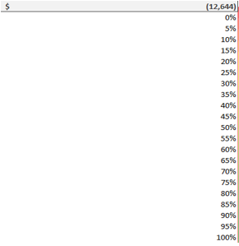

Appendix B- Input cells for digital method

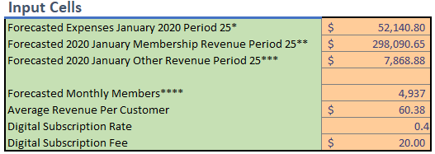

Appendix C- digital model output net loss

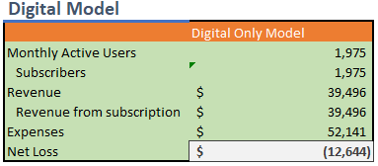

Appendix D- Two-way data table of net profit at $27 for digital method

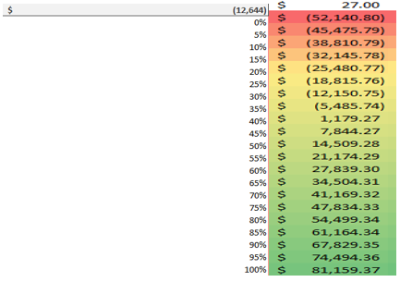

Appendix E- Blended model output

